**How to Install Git Bash:**

Link: <https://git-scm.com/download/win>

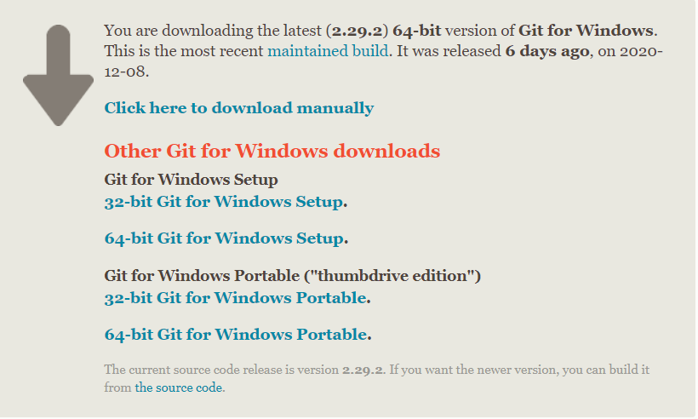

Step 2: Choose 64-bit Git for Windows Portable

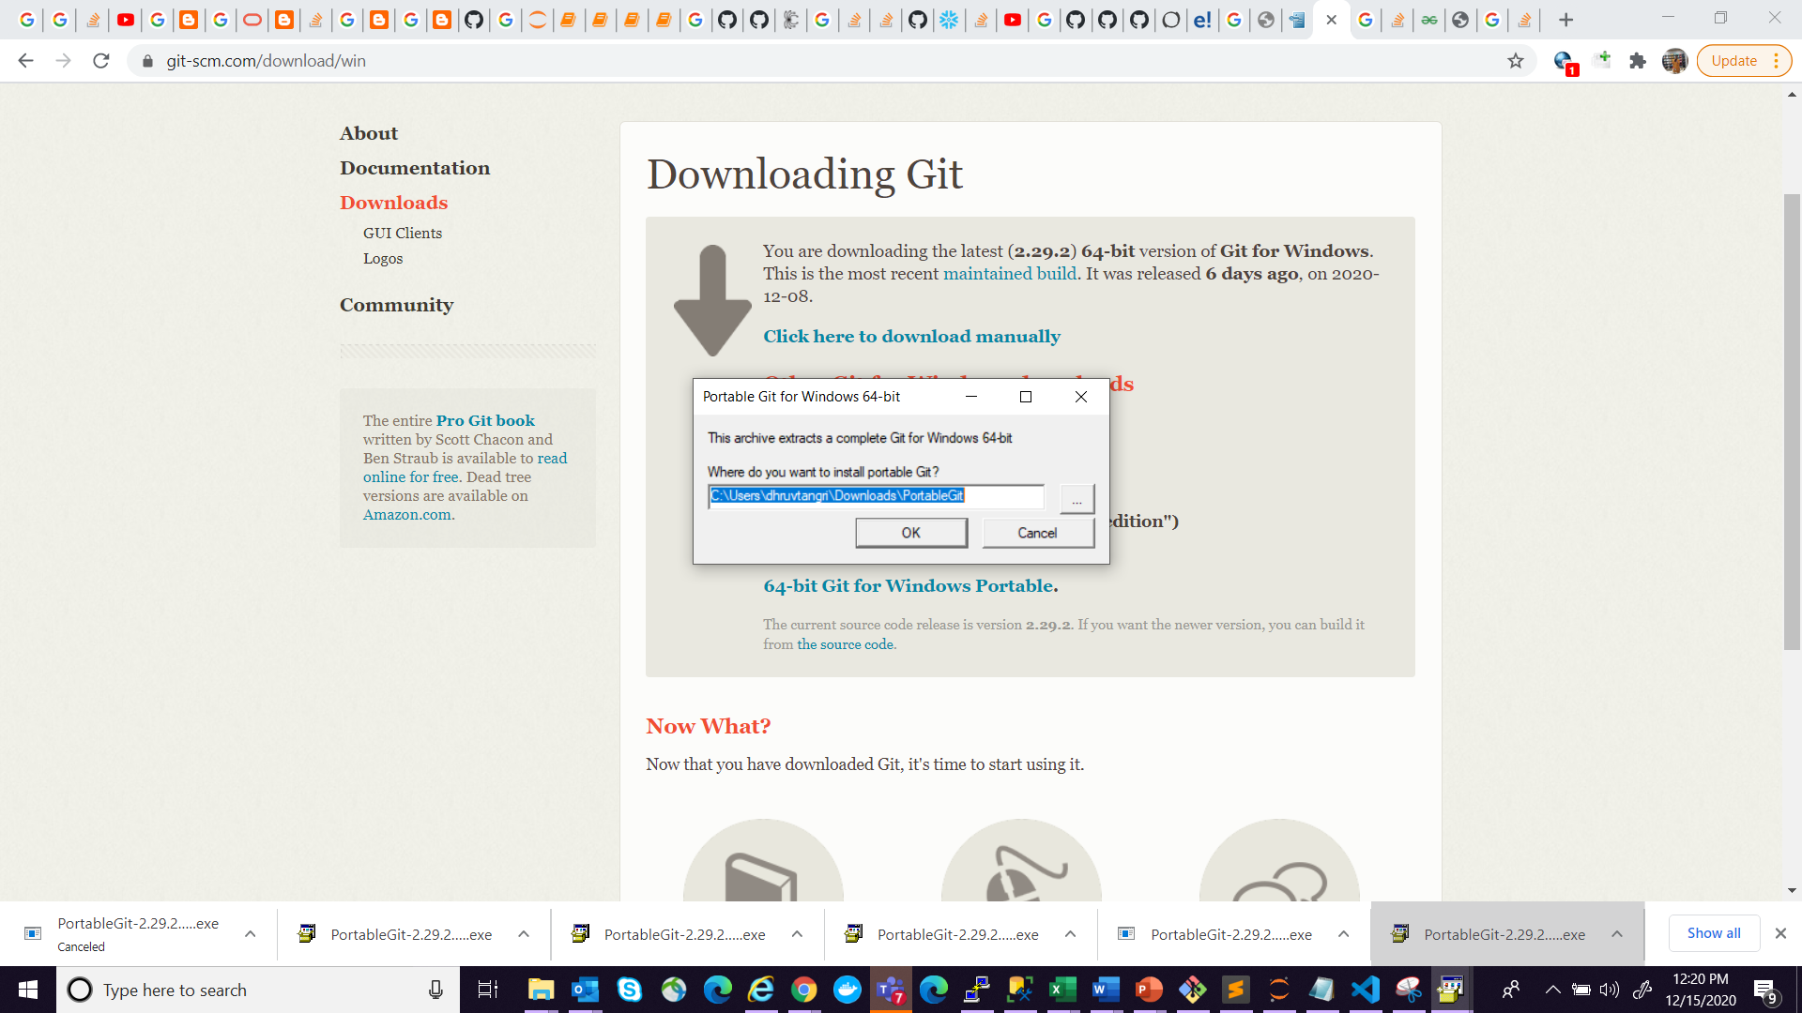

Step 3: Select the path

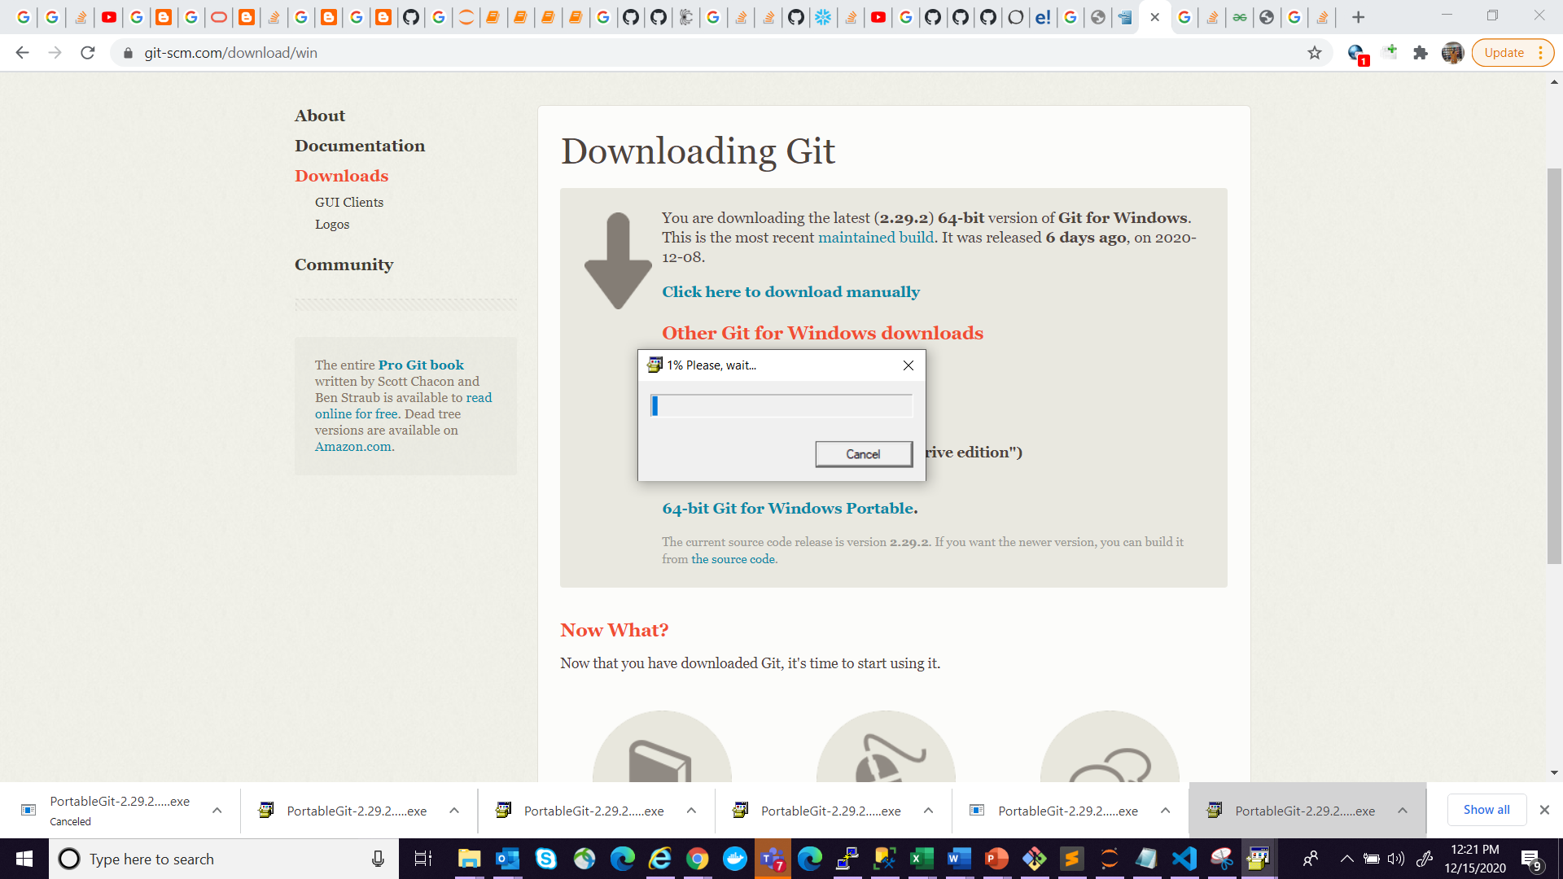

Step 5: Let it install

Step 6: Go to the location where you Git is installed.

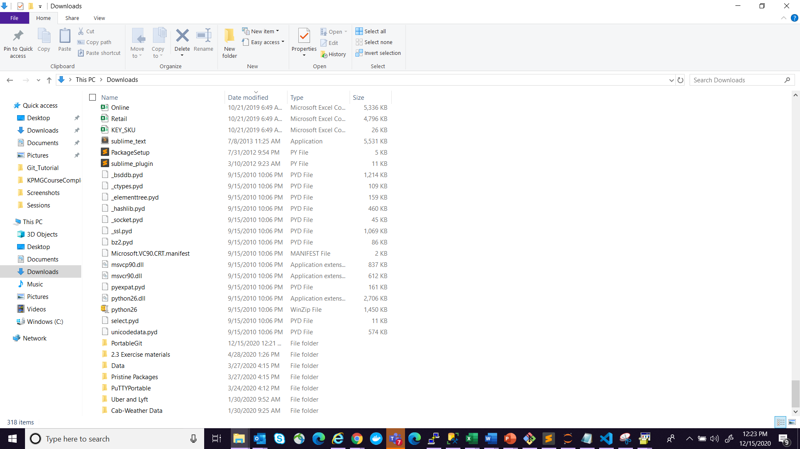

Step 7: Click the folder and open Git Bash.

**Note: Please Install VS code too. It will be helpful.**